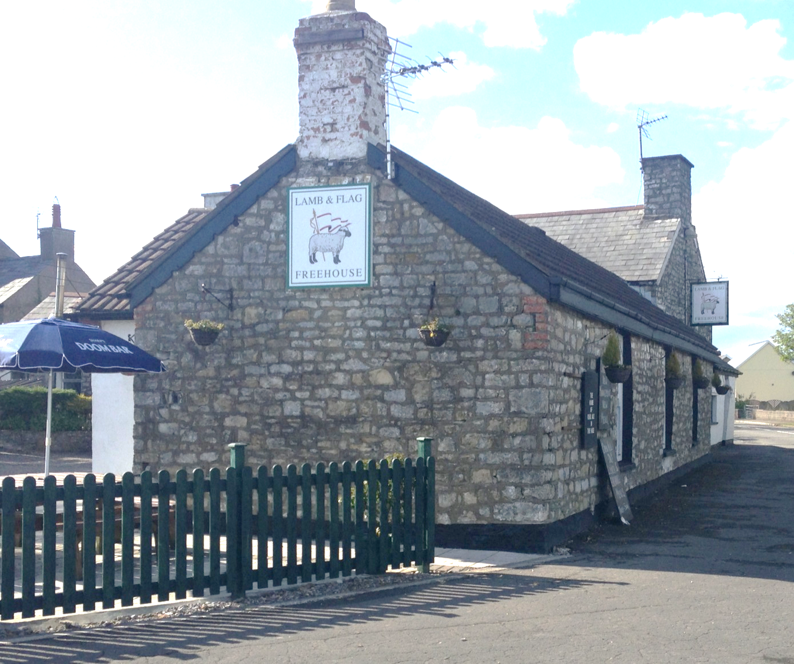
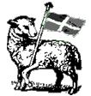
Lamb & Flag
Wick
Tel: 01656 890278
Find us on Facebook/lamb&flagwick
Starters

Prawns In Filo Pastry £3.95
Garlic Mushrooms £3.95
Cheesy Garlic Bread £3.45
(All Served With Garden Salad)
Soup of the Day with a Crusty Roll £2.95

Burger Bar
All £5.95
Butchers Lamb & Mint
Butterfly Chicken
Butchers Beef

(All Served With Chips & Garden Salad)

Hot Off The Grill

8oz Butchers Rump Steak £8.95
Mixed Grill (8oz Rump Steak, Sausage & 4oz Gammon) £11.95
Surf & Turf (8oz Rump & Prawns) £10.95
10oz Gammon £7.95
(All Served With Choice of Potato, Onion Rings, Pan Fried Tomato and Mushrooms)

Baguettes & Baked Potatoes
£4.95
Various Fillings on Request

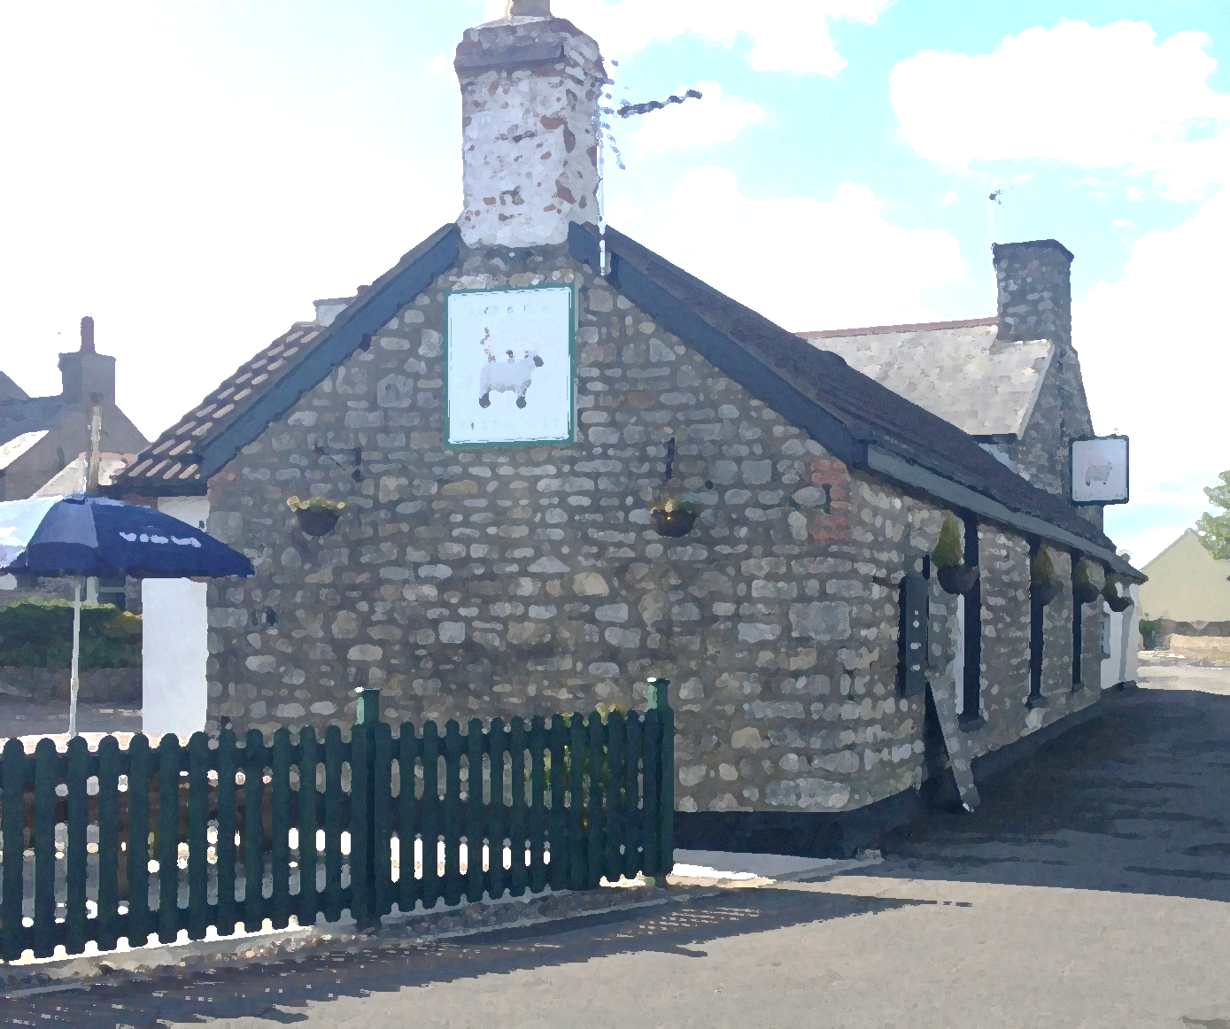
Lamb & Flag
Wick

Main Menu
(All Served With a Choice of Potato, Garden Salad or Peas)
All £6.95

Pie of the Week
Butchers Cut Ham & Eggs
Butchers Faggots
Curry of the Week
Topped Butterfly Chicken
Cajun
Garlic & Herb
Bacon, BBQ Sauce and Cheese
Battered Cod
Vegetable Curry
Ploughman’s Salad
Prawn Salad

Side Orders

Peppercorn Sauce £1.95
Garlic Bread £1.95
Cauliflower Cheese £1.95
Bowl of Chips £1.95

